Is wasting a problem or a resource?
People, especially in Europe generate large amounts of waste: food waste, construction waste, industrial waste, old televisions, batteries, plastic bags, paper and the list goes on. In this project we pay attention to three areas: water waste, food waste and energy waste. They are closely linked to our consumption and production patterns.
Some people tend to forget turning off the tap properly (Photo 1), and because of this, the amount of wasted water can be tens of litres in just one household. The same is true for toothbrushing, some people let the water run until they finish brushing their teeth. This means a lot of clean drinking water goes to waste. We could reduce our water usage by taking showers, instead of taking baths. Also, by using motion sensor taps, we could drastically reduce the amount of water wasted.
A lot of people forget to switch off the lights after leaving the room ( Photo2), with this they waste a lot of energy. There are a lot of halogen light bulbs in use, even though they are less energy saving than their newer ”relatives” (Photo3). If we turn off the lights upon leaving the room, and use modern led light sources, we can save lots of precious energy.
Food waste is a significant issue in our environment (Photo 4), especially in canteens and shops. There we see a huge amount of food being thrown away. Supermarkets destroy huge amounts of food that is still edible because the food has expired. In many cases, food is thrown away on the very first day of its expiry date. What is more, they are thrown away not because of expiry but because of a beauty defect.
In addition, according to our sources, on an average day in a primary school, approximately 30 liters of slop is produced by mixing together the leftover food. In our opinion, schools should donate the leftover food to the homeless and people in need, reducing the number of hungry people and reducing the amount of food thrown away. Supermarkets should do the same, offering products destined for the waste bin for people who suffer from famine.
In conclusion, we think everybody can do little, simple things for their environment such as not leaving the tap on while brushing their teeth, turning the lights off when they are not in the room, not accumulating food unnecessarily. We are convinced that our future depends on how we can manage the problem of waste. In some cases waste can be turned into an energy source.
Appendix:
Photo 1
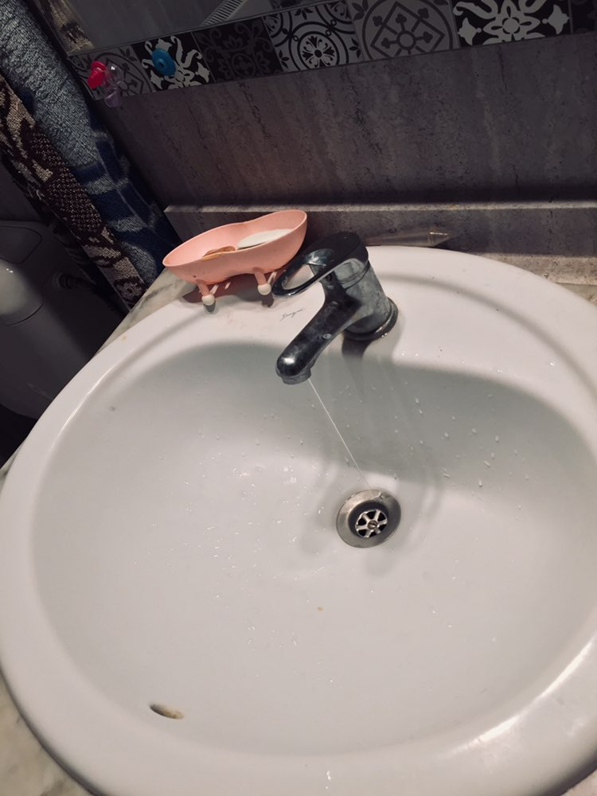

Photo 2
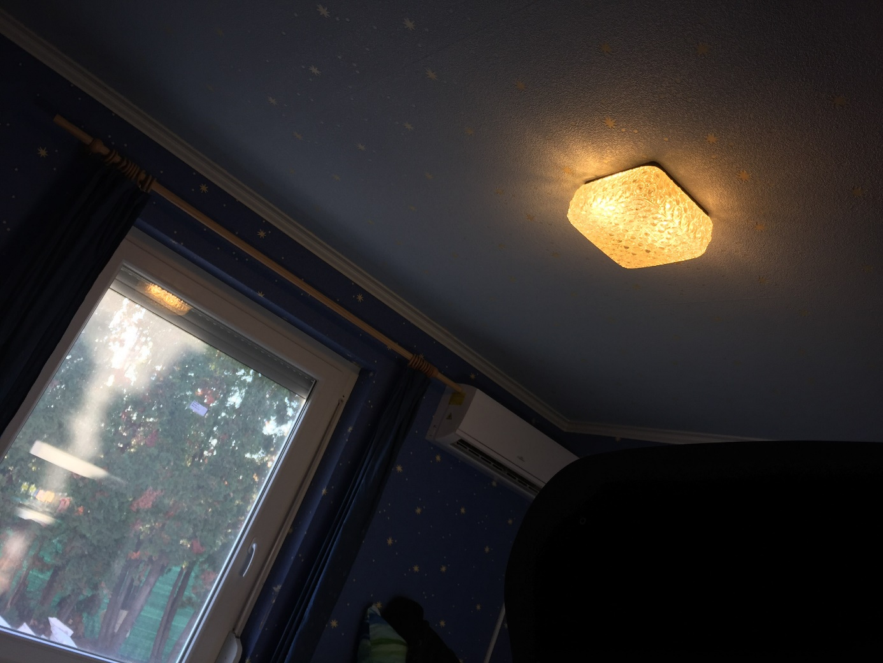
Photo 3
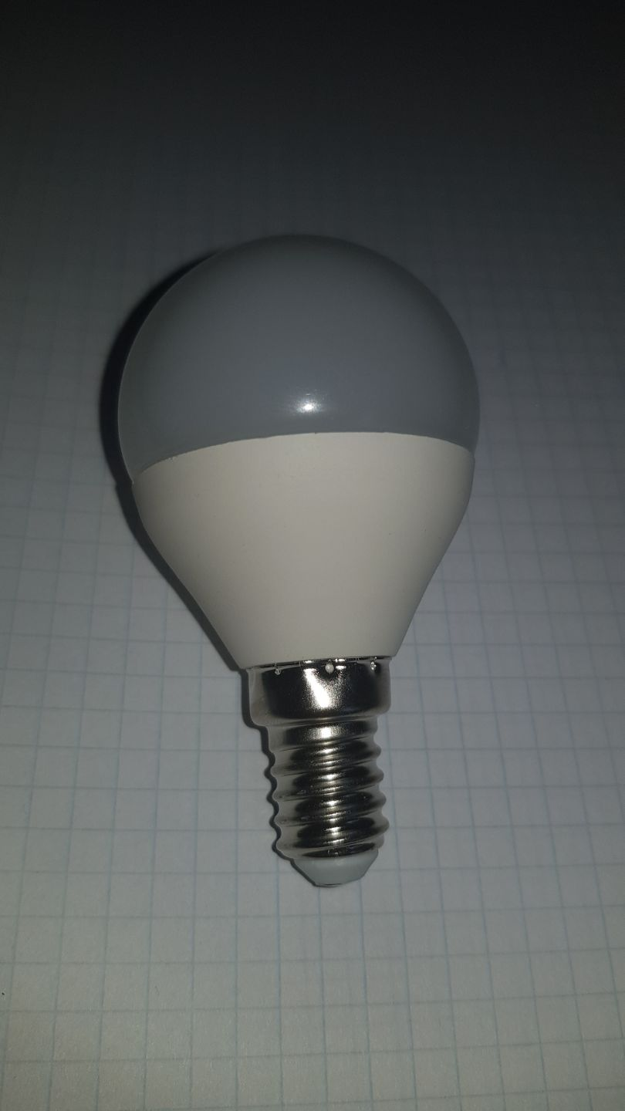
Photo 4
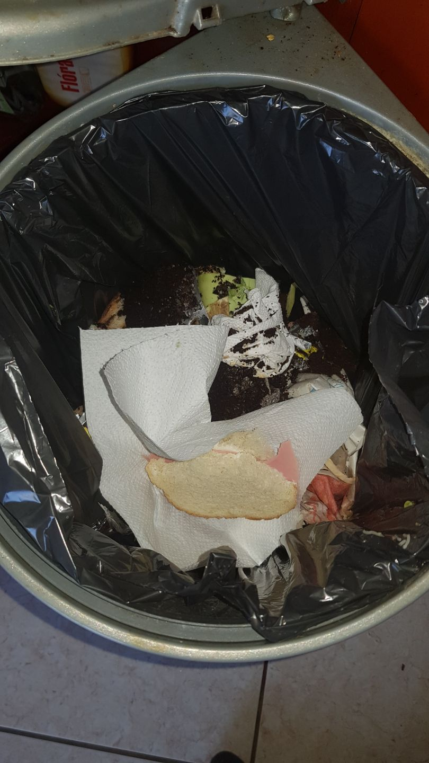

By ”Észt-osztók” ( Bernáth Kálmán Református Középiskola, Vác)

